

Assessment Cover Page

Student Full Name: | Andrea Diaz Medrano
Student Number: | 2026627
Module Title: | Machine Learning
Assessment Title: | CA 1
Lecturer/Supervisor: | Dr. Muhammad Iqbal
Assessment Due Date: | 29-09-2026
Date of Submission: | 15-11-2026

Contents
I. Introduction and Problem Domain 2
I.1. Introduction 2
I.2. Motivation 2
I.3. Problem Definition and Domain 2
I.4. Justification 2
II. Data Characterization, Pre-processing and Training Splits 2
II.1. Data Characterization and Pre-processing 2
II.2. Machine Learning Models Description 2
II.3. Evaluation Across Training Splits 2
III. Hyperparameter Tuning and Optimization 2
III.1. Purpose of Hyperparameter Tuning 2
III.2. Application of GridSearchCV 2
III.3. Optimal Parameters and Performance 2
IV. Results Comparison, Interpretation and Conclusions 2
IV.1. Modelling Results Comparison 2
IV.2. Analysis of Overfitting, Underfitting and Generalization 2
IV.3. Domain Interpretation and Feature Significance 2
IV.4. Conclusions 2
XI. References 2
XII. Appendix 3

I. Introduction and Problem Domain

I.1. Introduction

I.2. Motivation

I.3. Problem Definition and Domain

I.4. Justification

II. Data Characterization, Pre-processing and Training Splits

II.1. Data Characterization and Pre-processing

II.2. Machine Learning Models Description

II.3. Evaluation Across Training Splits

III. Hyperparameter Tuning and Optimization

III.1. Purpose of Hyperparameter Tuning

III.2. Application of GridSearchCV

III.3. Optimal Parameters and Performance

IV. Results Comparison, Interpretation and Conclusions

IV.1. Modelling Results Comparison

IV.2. Analysis of Overfitting, Underfitting and Generalization

IV.3. Domain Interpretation and Feature Significance

IV.4. Conclusions

XI. References

XII. Appendix
Use of AI Tools
I acknowledge the use of Chat GPT and Google Gemini for the purpose of get a possible dataset sources, Gantt diagram, high-level architectural diagram and to format references according to Harvard style respectively.

Declaration
By submitting this assessment, I confirm that I have read the CCT policy on academic misconduct and understand the implications of submitting work that is not my own or does not appropriately reference material taken from a third party or other source.
I declare it to be my own work and that all material from third parties has been appropriately referenced.
I further confirm that this work has not previously been submitted for assessment by myself or someone else in CCT College Dublin or any other higher education institution.

AI Declaration using the AI Fluency Framework
AI competence | Reflective prompts (to students) | Lecturer expectations | Student response
Delegation  Deciding whether & when to use AI | Identify the specific tasks in this assessment where you chose to use AI, and explain your reasoning. Where did AI add value? Where did you decide not to use it, and why? | You may use AI to support your learning and development of the application. Clearly identify where you used AI and where you completed the work independently. | In the “data sources” section, I used Chat GPT to help me find different online databases of corporate-level GHG emissions, which streamlined the search process.  In the “Project timeline” I used CHAT GPT to create an example of Gantt diagram.  In the section “High-level architectural diagram” I used Google Gemini, I uploaded my diagram and asked whether it was considered a correct High-level architectural diagram.  In the “References” section, I used Google Gemini to help format my references according to the Harvard style, as my version of Word does not include this citation style.
Description  How you prompted the AI | Include the exact prompts you used in your appendix (recorded on the AI Tools declaration). Reflect on how you communicated your goals to the AI — did you need to iterate or refine your prompts to get useful output? | You must provide the exact prompts and relevant AI outputs used during the development of your application. | For Chat GPT I used these prompts:  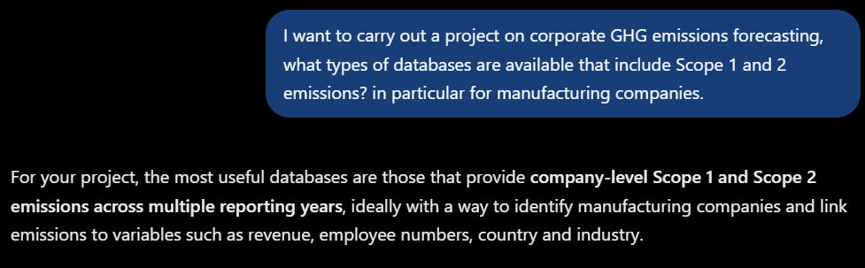  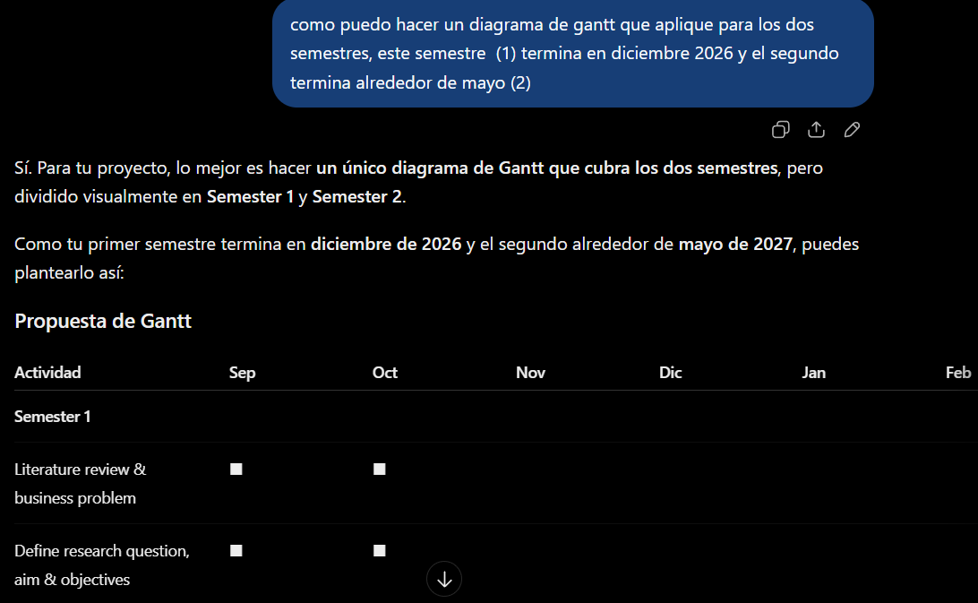  NOTE: This prompt was in Spanish, I request on Chat GPT “How can I make a Gantt chart that applies to both semesters? This semester (1) ends in December 2026, and the second one ends around May (2)”  For Google Gemini I used these prompts:  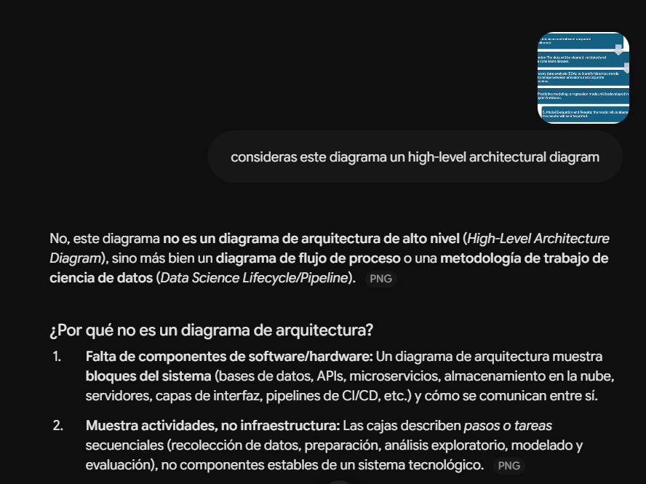  NOTE: I did this prompt in Spanish: I asked “Do you consider this diagram a high-level architectural diagram?”.  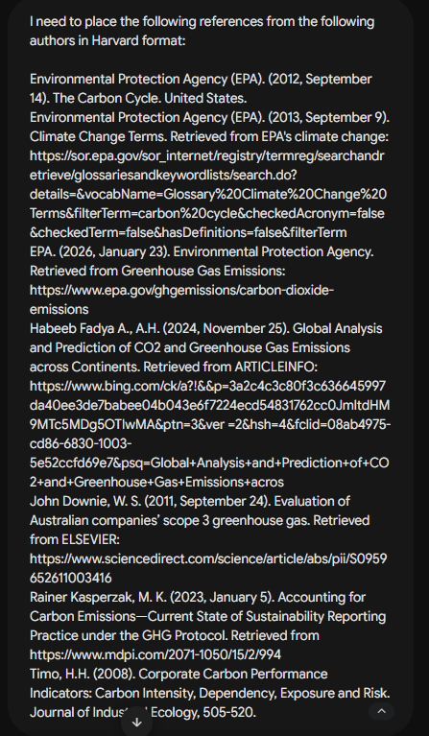
Discernment  Evaluating what the AI produced | In your reflection, critically evaluate the AI output: what did you accept, modify, or reject — and why? Assess accuracy, relevance, and quality. You are responsible for verifying all AI-generated content before submitting. | You are responsible for checking, testing and understanding any AI-generated code or suggestions before using them in your work. | For the “Data sources”, I identified Mycelium as the database best suited for my project. However, I also decided to look for two additional sources, as a backup in case the option suggested by Chat GPT fails to provide the target number of observations.  For the Gantt diagram I modified the diagram according to the project activities, dates and important milestones of it.  Regarding to the High-level architectural diagram, I looked for more information in the literature. However, I do find that this AI tool helped me better understand how to create a diagram of this type.  Regarding the references section, I verified that citations provided by Google Gemini were accurate and ensured that only those referenced within the document were included. I used the following link to confirm the Harvard style. https://library.cct.ie/ld.php?content_id=35451126
Diligence  Responsibility for your AI use | Declare all AI tools used and cite them here. Briefly outline how you considered data protection, copyright, and ethical responsibilities when choosing what to input into any AI system. Unauthorised use is subject to CCT disciplinary procedures. | Declare all AI tools used. Do not enter personal, confidential or sensitive information into AI tools. Any external sources used should be appropriately referenced. | Chat GPT and Google Gemini. In none of my prompts did I use personal or academic information that could compromise my document.

Adapted from the AI Fluency Framework (Dakan, Feller, Anthropic, 2025).

